CSS Assignments

1. Create a webpage to set the font color of the text.
2. Create a webpage to align the text to the center of the page , and the paragraph must be justified.
3. Create a web page to indent the paragraph text.
4. Display as follows:

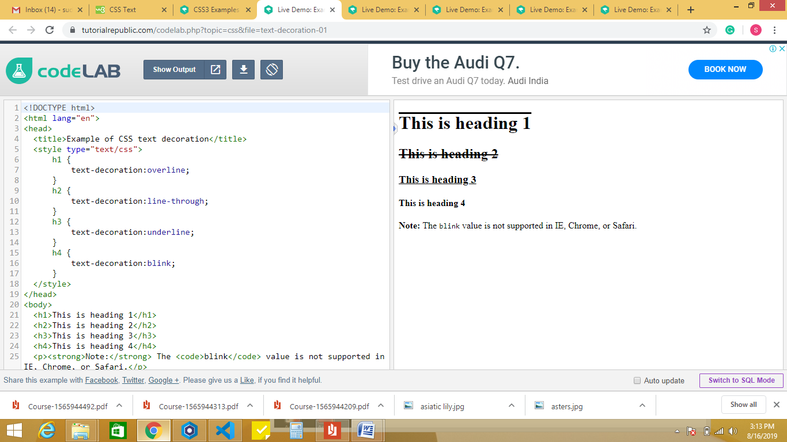

1. Write an html program to set the space between the lines of text of a paragraph.
2. Write a html code to wrap the text to some width.
3. Create a webpage to set all the properties of css font.
4. Create a webpage to create hyperlink, and style the text when clicked, visitied and hover.
5. Create a webpage to display as following using css

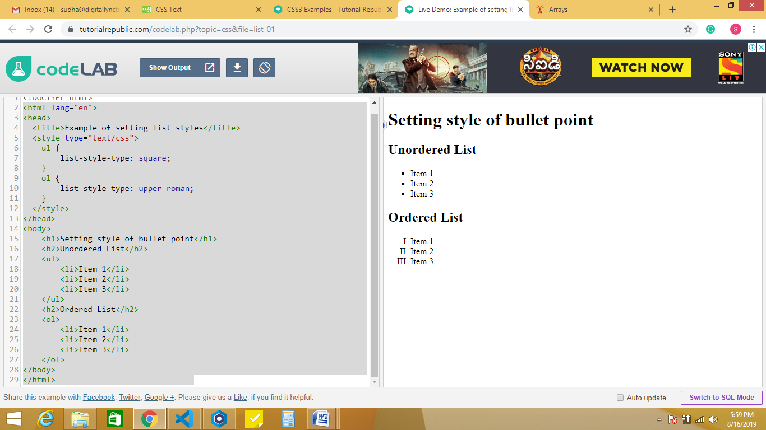

1. Create a simple dropdown menu on webpage.
2. Create a link box on a webpage.
3. Create a webpage to display a horizontal menu bar with menus Home, About us, Courses, contact us.
4. Create a webpage to set the borders of the table using CSS.
5. Create a webpage to display the background image.
6. Create a webpage give the dimensions of the block.
7. Create a webpage to collapse the table borders.
8. Create a table with empty cells along with the background image.
9. Create maximum width and height of a block.
10. Create a webpage to set the background repeatedly vertically or horizontally.
11. Create a webpage to set the background image that will not scroll with its containing element.
12. Create a webpage to set the overflow of the content in a table cell.
13. Create a webpage to add multiple backgrounds to an element.
14. Create a webpage to display as follows

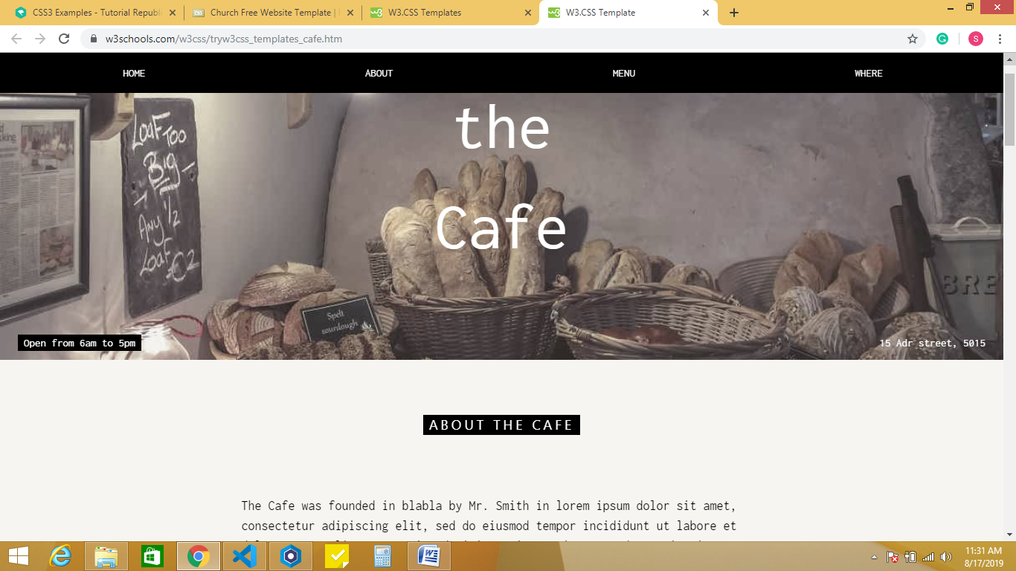

1. Create a web page to display the blocks :

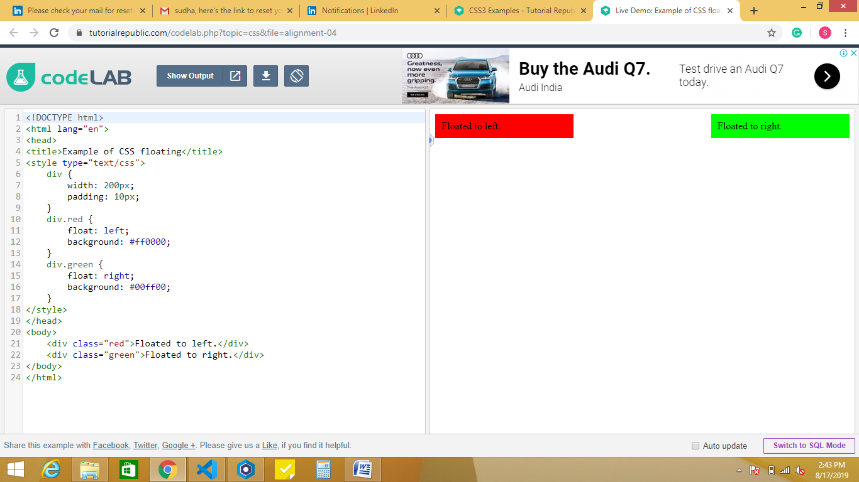

1. Create a web page to display overlapping of elements.
2. Create a web page to display rounded corner borders around the blocks.
3. Create a web as follows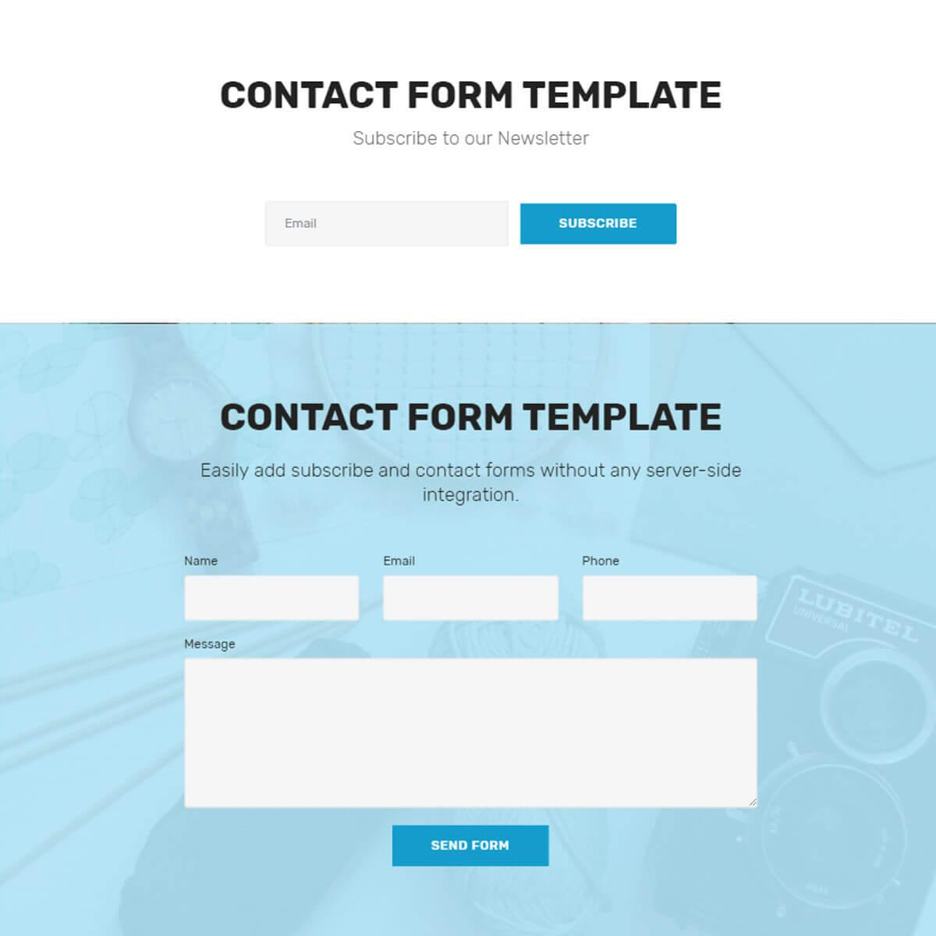
4. Create a webpage to display the text with desired margins.
5. Create a webpage to display the image as follows:

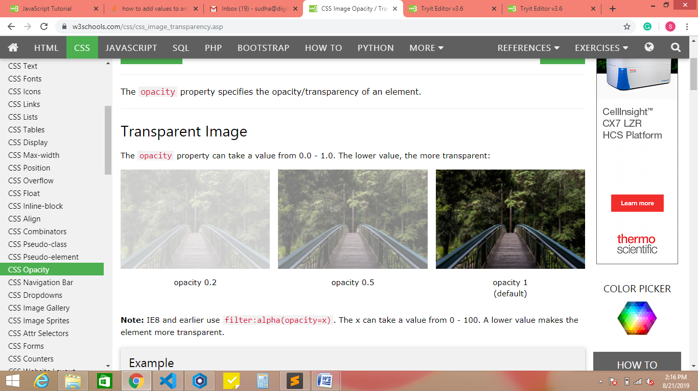

1. Create a webpage to demonstrate pseudo classes.
2. Create a webpage to display the login page, when the cursor is in text field, the background colour of text field must be changed to yellow.
3. Create a web page to display table and display data using css.
4. Create a web page to display the select options as follows

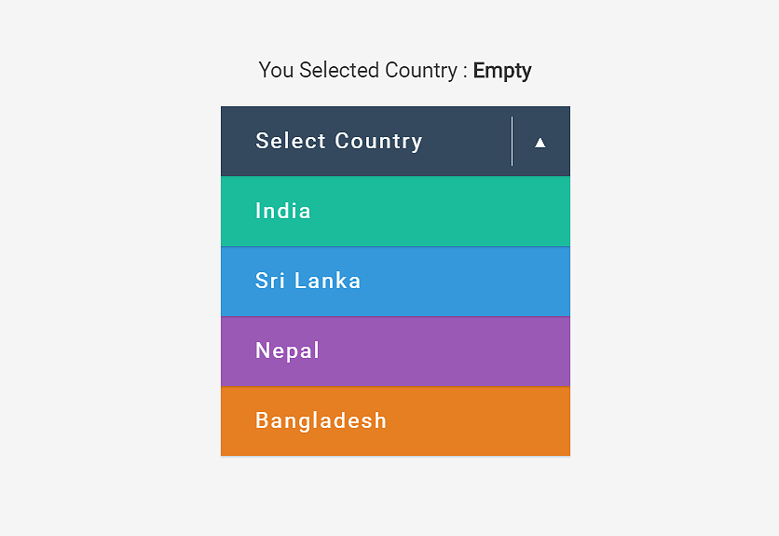

1. Create a webpage to design

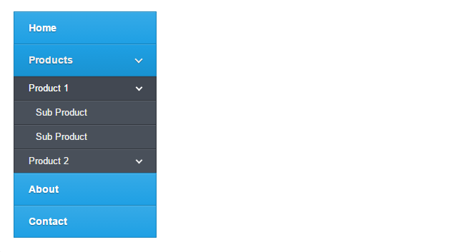

1. Create a web page to display the size of first letter of the line big, and first line as of red colour.
2. Create a webpage to display the background with linear gradient of colours.
3. Create a web page to display text with shadow effect
4. Create a web page to display multiple shadow effects

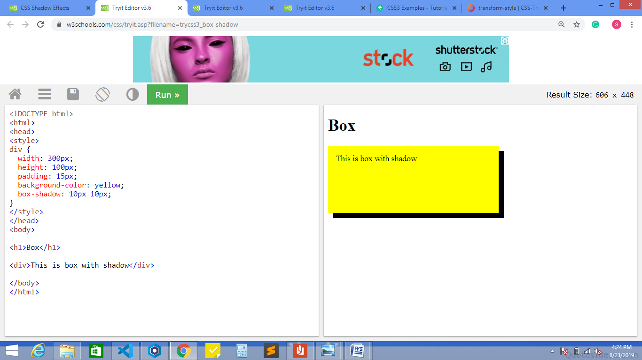

1. Create a webpage to display navigational menu bar. If the browser window is maximized the menus must appear as in fig 1, if the browser window size is less, the menus must appear as fig 2.

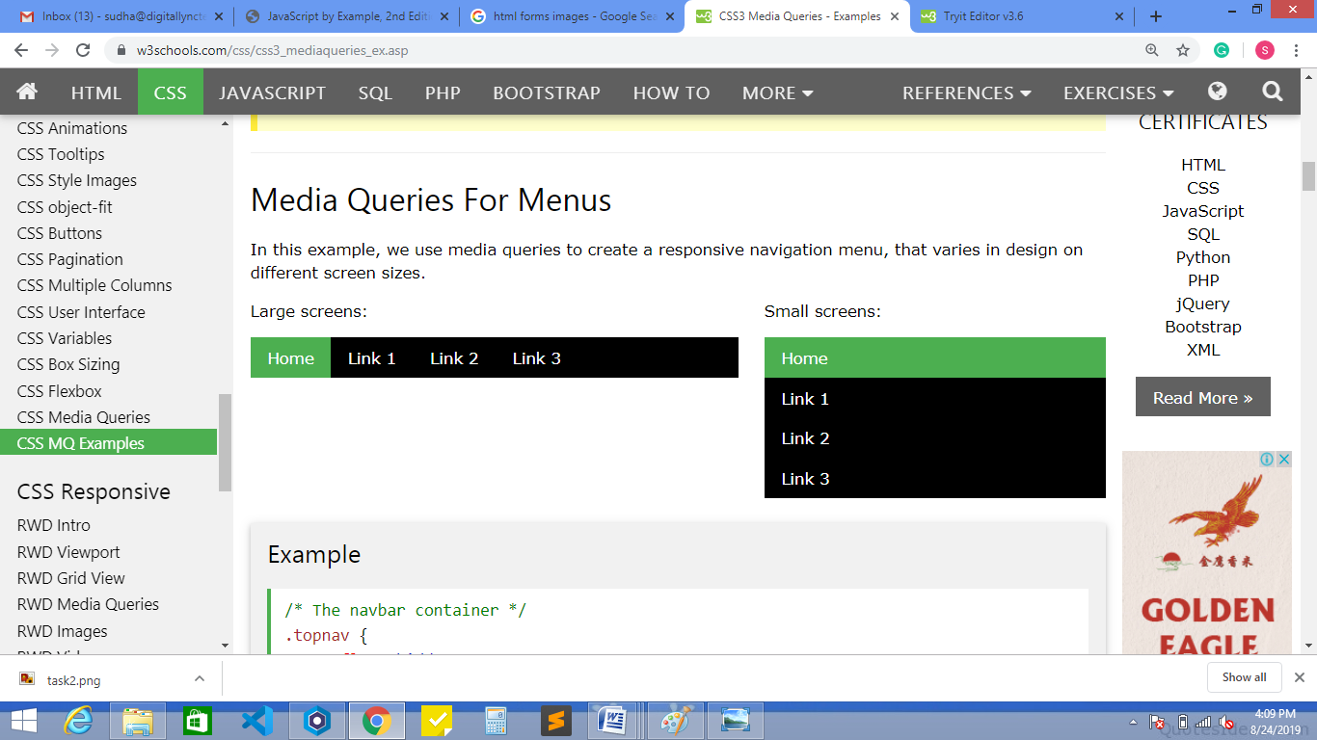

1. Create a web page to display as follows

